SIMATS ENGINEERING (SAVEETHA SCHOOL OF ENGINEERING)
Department of Computer Science and Engineering
ASSESSMENT TOOL 1 – Constraint-Based Problem Solving

Course Code: | CSA06 | Course Title: | Design and Analysis of Algorithms
CO Assessed: | CO5– Naturalization (BL5,BL6) | Assessment: | Assessment Tool 1 – Constraint Based Problem Solving
Weightage: | 30% of CIA | Total Marks: | 100 (2 Questions × 50 Marks)
CO5 Statement: | Analyze computational problems using backtracking techniques and complexity classes such as P, NP, NP-Hard, and NP-Complete for combinatorial problem solving.
Student Name: | A M RAKESH | Reg. No.: | 192424393
Section / Batch: | AIDS/24 | Date: | 29/08/2026

Instructions to Students
- • Answer BOTH questions. Each question carries 50 Marks. Total: 100 Marks.
• Apply backtracking techniques systematically for combinatorial problem solving.
• Clearly classify problems under P, NP, NP-Hard, and NP-Complete categories wherever required.
• Provide proper justification, state-space representation, and complexity analysis for all solutions.
• Neat presentation and logical explanation are mandatory.

Question Type | Focus Area | Questions | Marks
Constraint Based Problem Solving | Analyze combinatorial problems using backtracking and complexity classes such as P, NP, NP-Hard, and NP-Complete. | Q1 – Q2 | Q1 –50  Q2 –50
GRAND TOTAL: |  | 100 Marks

SECTION A – CONSTARINT BASED PROBLEM SOLVING

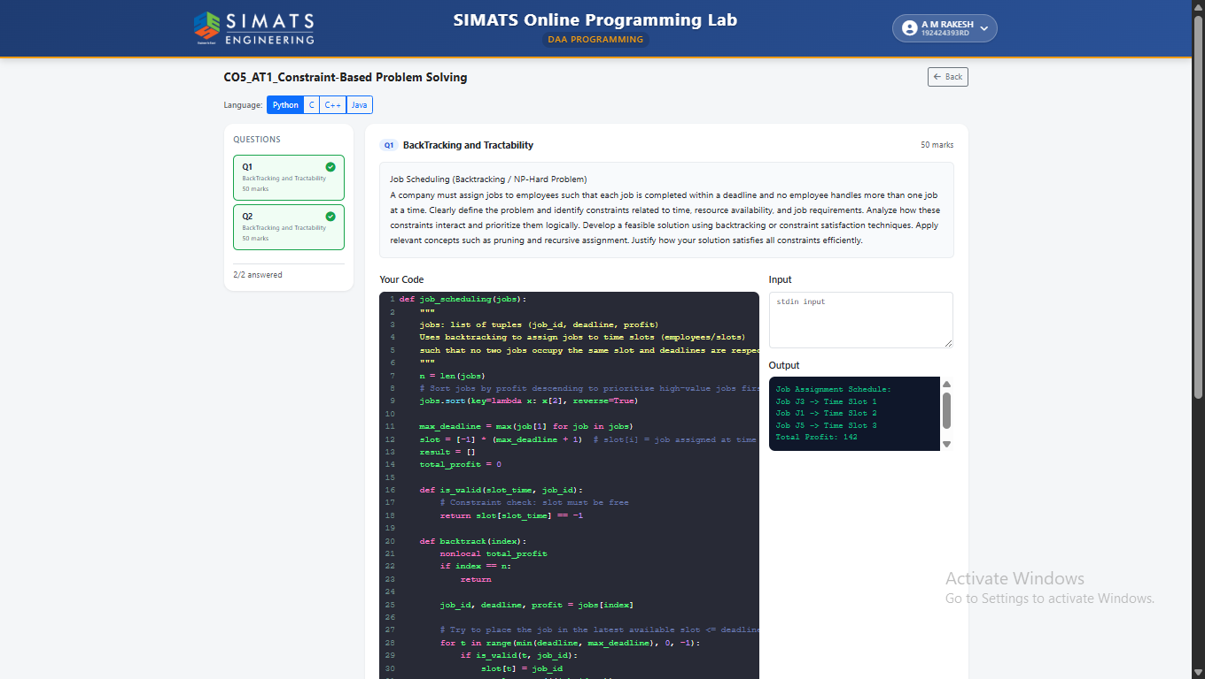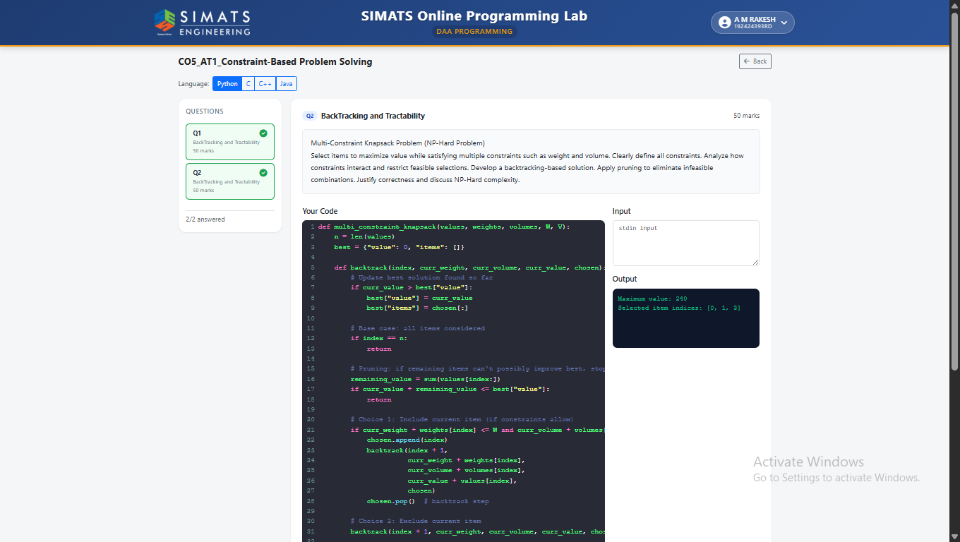

Code of Conduct
I A M RAKESH/192424393 (Name / Reg No) certify that this submission is my original work and that I have adhered to the guidelines specified for this assessment. I understand that any violation of academic integrity rules will result in disciplinary action.
Signature of the Student: 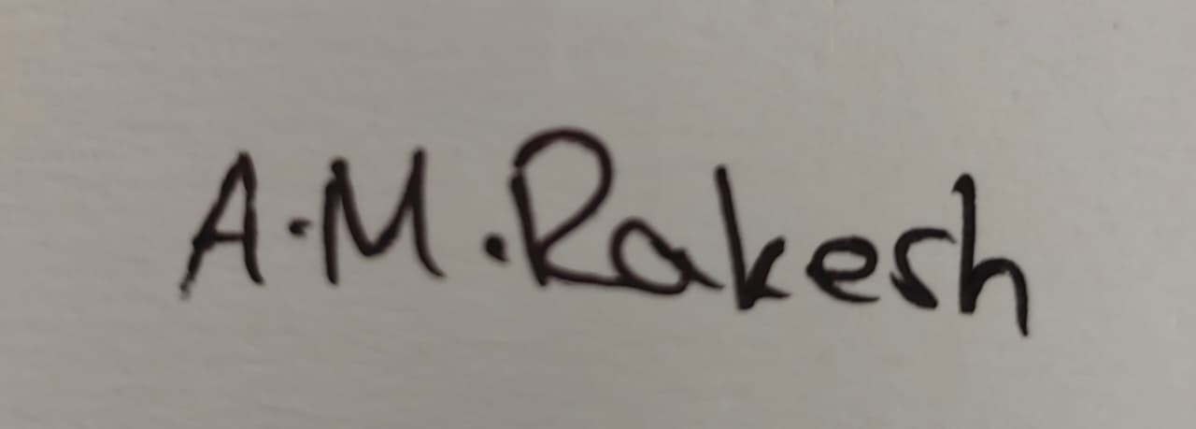
RUBRICS FOR CALCULATION
Criteria | Wt. | Level 4 – Exemplary | Level 3 – Proficient | Level 2 – Developing | Level 1 – Beginning
Problem Understandin g | 25% | Clearly defines the problem and identifies all relevant constraints accurately | Identifies most constraints with minor gaps | Partial understandi ng; misses key constraints | Fails to identify constraints correctly
Constraint Analysis | 25% | Analyzes constraints effectively and prioritizes them logically | Provides reasonable analysis with some prioritizatio n | Limited analysis; weak prioritization | No meaningful analysis or prioritization
Solution Development | 25% | Develops optimal and feasible solutions satisfying all constraints | Develops workable solutions with minor limitations | Solutions partially satisfy constraints | Solutions do not meet constraints
Application of Concepts | 15% | Effectively applies appropriate concepts, methods, or tools | Applies concepts with minor errors | Limited application; requires guidance | Unable to apply relevant concepts
Justification | 10% | Provides strong justification for decisions with logical reasoning | Provides justification with some clarity | Weak or unclear justification | No justification provided

Marks Evaluation:
Question No. | Problem Understanding  (25%) | Constraint Analysis  (25%) | Solution Development  (25%) | Application of Concepts  (15%) | Justification  (10%) | Total Marks (Each – 50)
Q1
Q2
Overall Total (100)

Faculty In-charge | Course Coordinator | Head of Department
Signature: _______________ | Signature: _______________ | Signature: _______________
Date: ___________________ | Date: ___________________ | Date: ___________________

